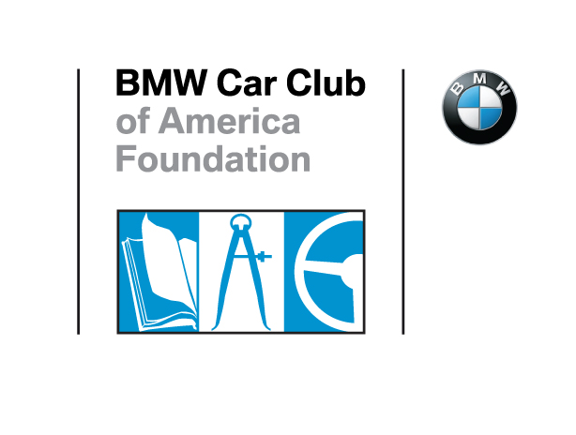
Contact: Andrea Galehouse, (864) 329-1919, andrea.galehouse@bmwccafoundation.org
Facebook: https://www.facebook.com/bmwccafoundation
Twitter: http://twitter.com/FoundationBMWCC
LinkedIn: https://www.linkedin.com/company/bmw-car-club-of-america-foundation-inc.
FOR IMMEDIATE RELEASE
BMW CCA Foundation Awarded $11,741.13
THE BMW CCA has awarded the BMW CCA Foundation $11741.13 as part of the Charity Matching Funds Program which acknowledges charitable or public service activities of the BMW CCA Chapters.
Greer, SC, April 12, 2016 - The BMW Car Club of America has awarded the BMW CCA Foundation $11741.13 as part of a program to recognize BMW CCA Chapters that conduct public service and charitable fund-raising activities and community or public service involvement projects in support of their communities and those in need.
The BMW CCA Foundation would like to extend our most sincere appreciation to the BMW CCA and to the Chapters who contributed in 2015 to their communities and to the BMW CCA Foundation.

Alleghey
Bayou
Bluegrass Bimmers
Boston
Buckeye
Choo –Choo Bimmers
Connecticut Valley
Delaware Valley
Everglades
First Coast
Genesee Valley
Heart of Dixie
Houston
Illini
Iowa
Kansas City
Lone Star
Los Angeles
Motor City
National Capital
New Jersey
New York
Nittany Bimmers
North Star
Patroon
Peachtree
Rocky Mountain
San Diego
Sandlapper
Sierra
Smoky Mountain
St. Louis
Tarheel
Windy City

About BMW Car Club of America Foundation
The BMW Car Club of America Foundation is a non-profit organization dedicated to the promotion of teen driver safety and the preservation of BMW history. Established in 2002 in Greenville, SC with initial capitalization from the BMW Car Club of America, the Foundation focuses on three initiatives to foster educational programs for the automotive community and be a significant repository of BMW information and history: Street Survival® teen driver safety program; the Library, Archive & Museum Program; and the Conservation and Preservation Program.
Through “The Ultimate Driving Community…Building the Foundation” Capital Campaign launched in 2013, the Foundation has raised $2.1 million of the $7 million required to support and grow these initiatives that will help save lives and preserve the legacy of BMW’s heritage.
# # #

